A000- Eur-Bulgaria-Madara-Thrace-Rider-Horseman-Marble-150 CE

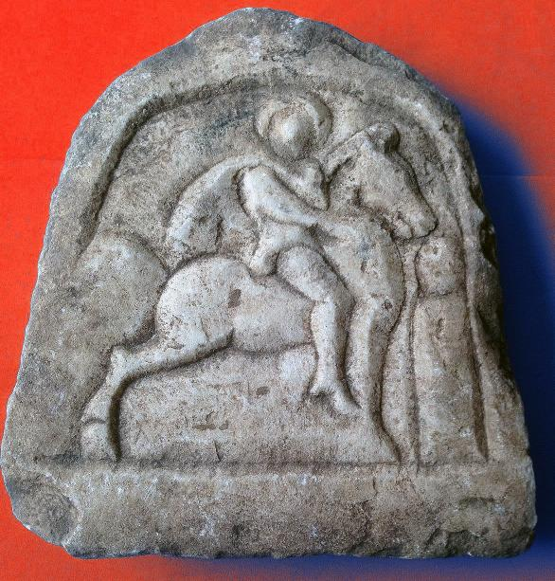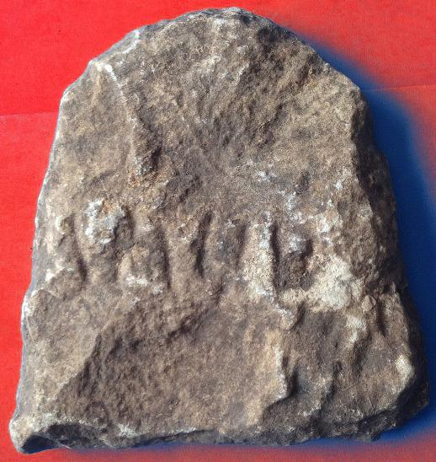

Figs. 1-2. Eur-Bulgaria-Madara-Thrace-Rider-Horseman-Marble-150 CE

Case no.: 3

Accession Number:

Formal Label: Eur-Bulgaria-Madara-Thrace-Rider-Horseman-Marble-150 CE

**Display Description:**

Thracian Horseman or Rider, Marble votive tablet, 2nd century AD/CE, probably from the Madara Plateau, Bulgaria, based on its similarity to other votive tablets in the Madara Museum.

**The Thracian horseman** (Bulgarian: *Тракийски конник*) refers to a horseman deity dating to Paleo-Balkan mythology. In this Roman Period rendition the caped horseman with a halo is seated astride an erect, stationary steed, with his left hand holding his cape and his right hand pointing to an erect anthropomorphic corpse, as though he is offering a benediction to the dead. This iconographic portrayal suggests that this votive plaque was, therefore, intended for a deceased cavalryman.

In other iconographic portrayals of the Thracian Horseman he is often depicted as slaying a beast with a spear held in his right hand and sometimes accompanied by a hunting hound. A petroglyph-relief east of Shumen in northeastern Bulgaria, near the village of Madara is dated late 7th early 8th century, during the reign of Bulgar Khan Tervel (Petkov 2008: 5; see figure below). This relief testifies to the duration of the cult as it developed in Bulgaria only to finally merge into the image of St. George slaying the dragon.

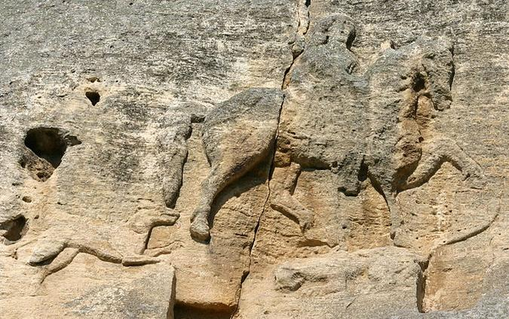

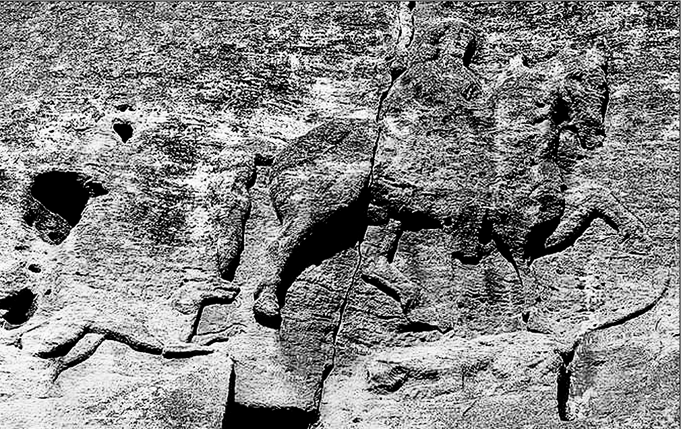

Bas relief petroglyph/relief of the Madara Horseman or Rider on a cliff of the Madara Plateau accompanied by his trusty greyhound and his horse trampling on a lioness. After <https://encrypted-tbn0.gstatic.com/images?q=tbn:ANd9GcTo1gtFW15JuszLKFz-pEZBqF1Vm_DzTIasAsvRgQjvmokzbItf>

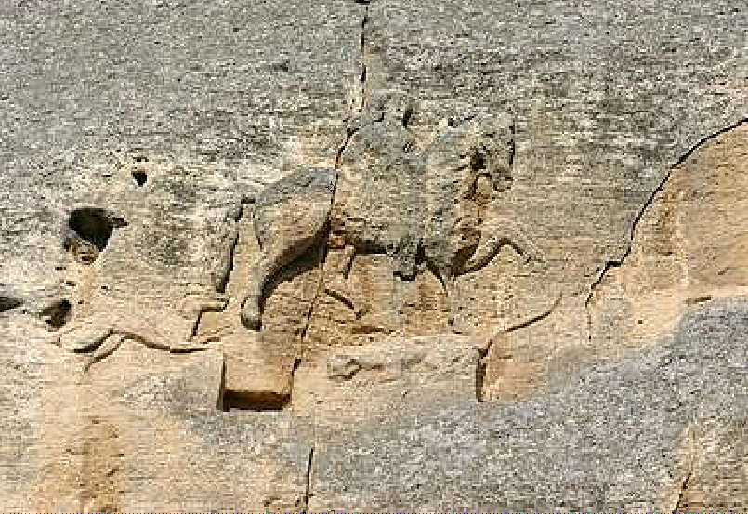

Madara, Bulgaristan, 1979; GPS N43 17 60 E27 8 60

The motif typically features a caped horseman astride a steed, with a spear poised in his right hand. He is often depicted as slaying a beast with a spear, though this features is sometimes absent.[[1]](https://en.wikipedia.org/wiki/Thracian_horseman" \l "cite_note-1)[[2]](https://en.wikipedia.org/wiki/Thracian_horseman" \l "cite_note-Nicoloff-2)[[3]](https://en.wikipedia.org/wiki/Thracian_horseman" \l "cite_note-3) The tradition is best illustrated in surviving artifacts from [Thrace](https://en.wikipedia.org/wiki/Thrace), [Macedonia](https://en.wikipedia.org/wiki/Macedonia_(Roman_province)), [Moesia](https://en.wikipedia.org/wiki/Moesia), and [Scythia Minor](https://en.wikipedia.org/wiki/Scythia_Minor) dating to the [Roman era](https://en.wikipedia.org/wiki/Roman_Empire), and is often found depicted on funerary statues. A very rare coin from Lycia in Asia Minor 310-315 CE shows a Riding God on Horseback which suggests the iconographic origin of the Thracian Rider God is in Lycia.

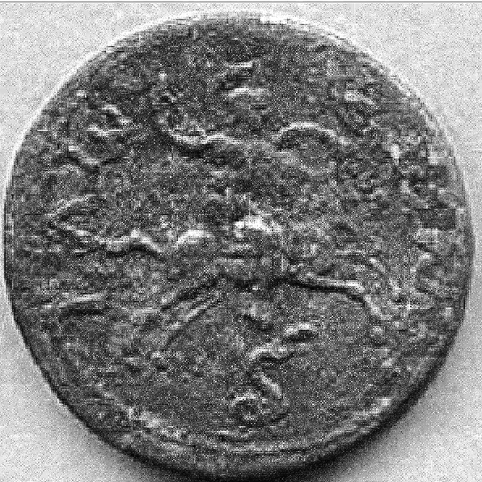  

Riding god on horseback right, snake below. Only seven known examples. Lycia: Phellus=Podalia=Rhodiapolis-Tlos\* von Aulock 310-315 CE, AE33 After http://mihalkam.ancients.info/giiilycia.html

**LC Classification:**

Date or Time Horizon:

Geographical Area:

**Map:**

**GPS coordinates:**

Cultural Affiliation: Roman period,

Medium: marble

Dimensions: H 16 cm , W 15 cm

Weight:

Condition:

Provenance:

**Discussion:**

**References:**

**Appendix 1:** Thracian horseman

From Wikipedia, the free encyclopedia

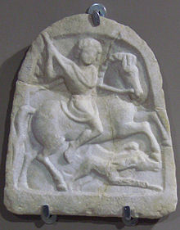

"Thracian horseman" votive tablet with the standard iconographic elements: the rider is holding a lance in his right hand aiming at a boar attacked by a hunting dog.

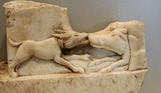

Fragment from a Thracian horseman marble relief: the hunting dog attacking the boar

The **Thracian horseman** (also "Thracian Rider" or "Thracian Heros") is the name given to a recurring motif of a horseman depicted in [reliefs](https://en.wikipedia.org/wiki/Relief) of the [Hellenistic](https://en.wikipedia.org/wiki/Hellenistic_period) and [Roman](https://en.wikipedia.org/wiki/Roman_Empire) periods in the [Balkans](https://en.wikipedia.org/wiki/Balkans) ([Thrace](https://en.wikipedia.org/wiki/Thrace), [Macedonia](https://en.wikipedia.org/wiki/Macedonia_(region)),[[1]](https://en.wikipedia.org/wiki/Thracian_horseman" \l "cite_note-1) [Moesia](https://en.wikipedia.org/wiki/Moesia), roughly from the 3rd century BC to the 3rd century AD).

Its depiction is in the tradition of the funerary steles of [Roman cavalrymen](https://en.wikipedia.org/wiki/Roman_cavalry), with the addition of syncretistic elements from Hellenistic and [Paleo-Balkanic](https://en.wikipedia.org/wiki/Paleo-Balkan_mythology) religious or mythological tradition. The Thracian horseman is depicted as a hunter on horseback, riding from left to right. Between the horse's hooves is depicted either a [hunting dog](https://en.wikipedia.org/wiki/Hunting_dog) or a boar. In some instances, the dog is replaced by a lion.

Inscriptions found in Romania identify the horseman as ***Heros*** (also *Eros, Eron, Herros, Herron*), apparently the word [*heros*](https://en.wikipedia.org/wiki/Greek_hero_cult)used as a proper name.[[2]](https://en.wikipedia.org/wiki/Thracian_horseman" \l "cite_note-2) The Cult of the Thracian horseman was especially important in [Philippi](https://en.wikipedia.org/wiki/Philippi), where the Heros had the epithets of [soter](https://en.wikipedia.org/wiki/Soter) (saviour) and *epekoos* "answerer of prayers". Funerary stelae depicting the horseman belong to the middle or lower classes (while the upper classes preferred the depiction of banquet scenes).[[3]](https://en.wikipedia.org/wiki/Thracian_horseman" \l "cite_note-3) The motif most likely represents a composite figure, a [Thracian](https://en.wikipedia.org/wiki/Thracians) heroes possibly based on [Rhesus](https://en.wikipedia.org/wiki/Rhesus_of_Thrace), the Thracian king mentioned in the Iliad,[[4]](https://en.wikipedia.org/wiki/Thracian_horseman" \l "cite_note-4) to which [Scythian](https://en.wikipedia.org/wiki/Scythians), [Hellenistic](https://en.wikipedia.org/wiki/Hellenistic_religion) and possibly other elements had been added.[[5]](https://en.wikipedia.org/wiki/Thracian_horseman" \l "cite_note-5)

In the Roman era, the "Thracian horseman" iconography is further syncretised. The rider is now sometimes shown as approaching a tree entwined by a serpent, or as approaching a goddess. These motifs are partly of Greco-Roman and partly of possible Scythian origin. The motif of a horseman with his right arm raised advancing towards a seated female figure is related to Scythian iconographic tradition. It is frequently found in Bulgaria, associated with [Asclepius](https://en.wikipedia.org/wiki/Asclepius) and [Hygeia](https://en.wikipedia.org/wiki/Hygeia).[[6]](https://en.wikipedia.org/wiki/Thracian_horseman" \l "cite_note-6) The motif of a standing goddess flanked by two horsemen, identified as [Artemis](https://en.wikipedia.org/wiki/Artemis) flanked by the [Dioscuri](https://en.wikipedia.org/wiki/Dioscuri), and a tree entwined by a serpent flanked by the Dioscuri on horseback is transformed into a motif of a *single* horseman approaching the goddess or the tree.[[7]](https://en.wikipedia.org/wiki/Thracian_horseman" \l "cite_note-7) Related to the Dioscuri motif is the so-called "Danubian Horsemen" motif of two horsemen flanking standing goddess.[[8]](https://en.wikipedia.org/wiki/Thracian_horseman" \l "cite_note-8)

The motif of the Thracian horseman is not to be confused with the depiction of a rider slaying a barbarian enemy on funerary stelae, as on the stele of Dexileos, interpreted as depictions of a heroic episode from the life of the deceased.[[9]](https://en.wikipedia.org/wiki/Thracian_horseman" \l "cite_note-9)

Under the Roman Emperor [Gordian III](https://en.wikipedia.org/wiki/Gordian_III) the god on horseback appears on coins minted at Tlos, in neighboring Lycia, and at Istrus, in the province of Lower Moesia, between Thrace and the Danube.[[10]](https://en.wikipedia.org/wiki/Thracian_horseman" \l "cite_note-10)

The motif of the Thracian horseman was continued in Christianised form in the equestrian iconography of both [Saint George](https://en.wikipedia.org/wiki/Saint_George_and_the_Dragon) and [Saint Demetrius](https://en.wikipedia.org/wiki/Saint_Demetrius).[[11]](https://en.wikipedia.org/wiki/Thracian_horseman" \l "cite_note-11)

## **References[**[**edit**](https://en.wikipedia.org/w/index.php?title=Thracian_horseman&action=edit&section=2)**]**

* 1. **[Jump up](https://en.wikipedia.org/wiki/Thracian_horseman" \l "cite_ref-1)^** Dimitrios C. Samsaris, Le culte du Cavalier thrace dans la vallée du Bas-Strymon à l' époque romaine (Recherches sur la localisation de ses sanctuaires), "Dritter Internationaler Thrakologischer Kongress (Wien, 2-6 juni 1980)", Bd. II, Sofia 1984, p. 284 sqq. - Dimitrios C. Samsaris, Le culte du Cavalier thrace dans la colonie romaine de Philippes et dans son territoire, "Ponto-Baltica" 2-3(1982-83)89-100
  2. **[Jump up](https://en.wikipedia.org/wiki/Thracian_horseman" \l "cite_ref-2)^** Nubar Hampartumian, *Moesia Inferior (Romanian Section) and Dacia*, Volume 74, Part 4 (1979), [[1]](https://books.google.ch/books?id=kdIUAAAAIAAJ&pg=PA16)
  3. **[Jump up](https://en.wikipedia.org/wiki/Thracian_horseman" \l "cite_ref-3)^** Richard S. Ascough, *Paul's Macedonian Associations: The Social Context of Philippians and 1 Thessalonians* (2003), [p. 159](https://books.google.ch/books?id=SXNtJ2A7dC8C&pg=PA159).
  4. **[Jump up](https://en.wikipedia.org/wiki/Thracian_horseman" \l "cite_ref-4)^** Rebecca West (21 December 2010). [*Black Lamb and Grey Falcon: A Journey Through Yugoslavia*](https://books.google.com/books?id=utUksPa017QC&pg=PT455). Open Road Media. p. 455. [*ISBN*](https://en.wikipedia.org/wiki/International_Standard_Book_Number) [*978-1-4532-0746-8*](https://en.wikipedia.org/wiki/Special:BookSources/978-1-4532-0746-8).
  5. **[Jump up](https://en.wikipedia.org/wiki/Thracian_horseman" \l "cite_ref-5)^** R. F. Hoddinott, *Early Byzantine Churches in Macedonia & Southern Serbia*, 1963, [58–62](https://books.google.ch/books?id=WoSuCwAAQBAJ&pg=PA58" \l "v=onepage&q&f=false)
  6. **[Jump up](https://en.wikipedia.org/wiki/Thracian_horseman" \l "cite_ref-6)^** Hoddinott (1963:58)
  7. **[Jump up](https://en.wikipedia.org/wiki/Thracian_horseman" \l "cite_ref-7)^** Hoddinott (1963:59)
  8. **[Jump up](https://en.wikipedia.org/wiki/Thracian_horseman" \l "cite_ref-8)^** Hoddinott (1963:59)
  9. **[Jump up](https://en.wikipedia.org/wiki/Thracian_horseman" \l "cite_ref-9)^** Hoddinott (1963:60)
  10. **[Jump up](https://en.wikipedia.org/wiki/Thracian_horseman" \l "cite_ref-10)^** [Sabazios on coins, illustrated in the M. Halkam collection.](http://mihalkam.ancients.info/giiilycia.html)
  11. **[Jump up](https://en.wikipedia.org/wiki/Thracian_horseman" \l "cite_ref-11)^** Hoddinott (1963:[61](https://books.google.ch/books?id=WoSuCwAAQBAJ&pg=PA61)). Sigfried J. de Laet (1994). [*History of Humanity: From the seventh to the sixteenth century*](https://books.google.com/books?id=ixCyd2lByggC&pg=PA233). Routledge. pp. 233–. [*ISBN*](https://en.wikipedia.org/wiki/International_Standard_Book_Number) [*978-92-3-102813-7*](https://en.wikipedia.org/wiki/Special:BookSources/978-92-3-102813-7).Christopher Walter (2003). [*The Warrior Saints in Byzantine Art and Tradition*](https://books.google.com/books?id=BRju9VQdW3QC&pg=PA88). Ashgate. pp. 88–. [*ISBN*](https://en.wikipedia.org/wiki/International_Standard_Book_Number) [*978-1-84014-694-3*](https://en.wikipedia.org/wiki/Special:BookSources/978-1-84014-694-3). c.f. the badly damaged wall painting of St George in the ruins of [Đurđevi stupovi](https://en.wikipedia.org/wiki/Đurđevi_stupovi), Serbia (c. 1168), see Hoddinott (1963:[61](https://books.google.ch/books?id=WoSuCwAAQBAJ&pg=PA61)).
* Dumitru Tudor, Christopher Holme (trans.), *Corpus Monumentorum Religionis Equitum Danuvinorum (CMRED)* (1976)
* Nora Dimitrova, "Inscriptions and Iconography in the Monuments of the Thracian Rider," *Hesperia* 71.2 (2002) 209–229.
* Grbić Dragana (2013). [*"The Thracian hero on the Danube new interpretation of an inscription from Diana"*](http://www.doiserbia.nb.rs/ft.aspx?id=0350-76531344007G). Balcanica. **44**: 7–20.

## **Gallery[**[**edit**](https://en.wikipedia.org/w/index.php?title=Thracian_horseman&action=edit&section=1)**]**

**Hunter motif**

* 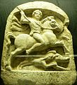

Thracian horseman with hound and boar, Greek inscription (3rd century BC), Teteven museum

* 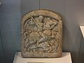

Thracian horseman attacking a lion which is in turn attacking its prey. Madara Museum, Bulgaria

* 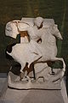

Statue of a Thracian horseman with lion, 3rd century, National History Museum of Bulgaria

* 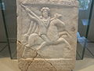

Thracian horseman, funerary stele with Greek inscription, Madara Museum, Bulgaria

* 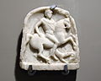

Thracian horseman with hound, marble votive tablet, Stara Zagora regional history museum

**Serpent-and-tree**

* 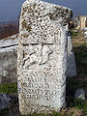

Thracian horseman with hound and serpent-entwined tree, funerary stele for one Caius Cornelius at [Philippi](https://en.wikipedia.org/wiki/Philippi).

* 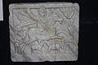

Thracian horseman with hounds, a serpent-entwined tree and a footman (3rd century), Muzeul de Istorie Naţională şi Arheologie, Constanța

* 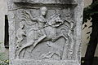

Thracian horseman with hounds, footman and tree, Haskovo Historic Museum, Bulgaria

* 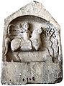

Thracian horseman with a serpent-entwined tree, Histria Museum, Romania

* 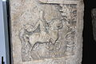

Thracian horseman with serpent-and-tree, the National History Museum of Bulgaria

* 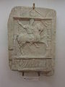

Thracian horseman with serpent-and-tree (2nd century), Burgas Archaeological Museum, Bulgaria

* 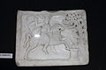

Thracian horseman with serpent-and-tree, Expoziţia Cultura Cucuteni

**Rider and goddess**

* 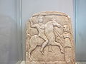

Thracian rider of "Scythian" type, with raised hand, riding towards female figure, Madara Museum, Bulgaria

* 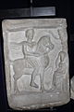

Horseman approaching seated female figure under a tree, Constanta Museum

**Greco-Roman comparanda**

* 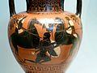

[Black figure](https://en.wikipedia.org/wiki/Black-figure_pottery) Thracian cavalrymen vs. armored Greek foot soldier (Getty Villa Collection, c. 520 BC)

* 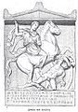

Stele of Dexileos (c. 390 BC)

* 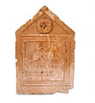

Funerary relief of a Roman cavalryman (2nd/3rd century)

* 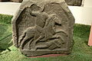

Funerary relief of a late (4th/5th century?) Roman cavalryman trampling a barbarian warrior, [Roman Britain](https://en.wikipedia.org/wiki/Roman_Britain)([Chester](https://en.wikipedia.org/wiki/Chester), [Grosvenor Museum](https://en.wikipedia.org/wiki/Grosvenor_Museum))

* 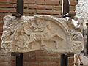

A fragment of a decorated frieze at [Felix Romuliana](https://en.wikipedia.org/wiki/Felix_Romuliana), a palace built by the emperor Galerius in modern-day Serbia. The fragment depicts a rider wielding an ax, and a shield-bearing soldier on foot.

* "Danubian Horsemen" (Artemis flanked by the Dioscuri), votive plate found in Demir Kapija, Macedonia

**Medieval comparanda**

* 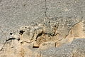

The [Madara Rider](https://en.wikipedia.org/wiki/Madara_Rider), equestrian rock relief in Bulgaria (c. 700)

* 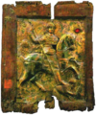

"St George of Labechina", [Racha](https://en.wikipedia.org/wiki/Racha), Georgia (11th century), known as the oldest extant equestrian depiction of St George (but note that the horseman is trampling a human opponent rather than a dragon)

* 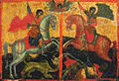

Equestrian depiction of Saints George and Demetrius

**APPENDIX 2:**

MADARA HORSEMAN

Geza Feher

What is now left of the Madara texts is sufficient to reveal, together with the regional and stylistic particularities of the relief, the time when it was carved and its nationality. However, the correct deciphering of the texts and the relief required suitable conditions. The scholars could reach the rock only after the construction of a scaffolding. Such scaffolding was first erected in 1895 and later in 1905 when the first plaster cast of the relief was made. The last scaffolding was made in 1954 when more than thirty Bulgarian scholars from different disciplines related to the various aspects of the carvings studied it for a month, carefully comparing each detail. The carving was observed under different lighting including strong flood lighting during the night. All the documentation is kept in the Institute of Archaeology of the Bulgarian Academy of Science. The results are summed up in a volume that was published by the Bulgarian Academy of Science in 1956.

But before these final conclusions were agreed upon, the origins, dating and meaning of the Madara Horseman were interpreted in various ways and were often the subject of heated discussions. This is by no means surprising - the monument on the huge Madara rock is very unusual and has no parallel. Furthermore, the popular subject of the hunting horseman or the victorious ruler led many scholars to different conclusions.

Scholars learned of the Madara Horseman for the first time only a few years before Bulgaria became independent. In 1872 the Hungarian traveler Felix Kanitz visited some places far from the main roads of the Ottoman Empire and one of them was Madara. He wrote in hi book "Danube Bulgaria and the Balkan" that he noticed through field glasses Latin letters and the word "sever". This made him assume the relief was carved during the rule of the Roman Empire. F. Kanitz also made a drawing of the monument with parts of the text but when his book was published in 1878 the engraver changed it considerably, with many mistakes. Thus the first publication was responsible for some of the first mistakes in the interpretation of the relief and texts.

The eminent Czech historian Konstantin Irechek saw the Madara Horseman in 1884. He observed it, too, from a distance but correctly noticed that the texts are in Greek. At first he considered the rider to be a Thracian. However, a few years later two other Czech scholars who made great contributions to Bulgarian studies, the brothers Skorpil, erected a scaffolding and made a more detailed study of the relief. Irechek agreed with them that the texts are from the early Bulgarian pagan period.

At first Karel Skorpil came to the wrong conclusion and defined the horseman as the Thracian Heros. Two years later, after further research of the details, and particularly of the clothing of the rider he decided this was not a Thracian. Skorpil was the first to presume that this was the image of the Bulgarian Khan Krum. This was one of the hypotheses which later on acquired great popularity.

Interest in the Madara Horseman grew. Scholars from the Vienna Academy of Science studied it. The Russian archaeologist and historian F. I. Uspenski was especially interested and was the first (1901) to declare the extreme importance of the Madara relief. He called it "most remarkable" and "absolutely unique". Uspenski confidently placed the work among the "most ancient and intriguing old Bulgarian monuments". Later, in 1929, the Russian byzantologist H. P. Kondakov dated the relief back to the Bulgarian khans of the beginning of the 8th century. He stressed the difference between the Madara Horseman and the large forms of the Persian rock reliefs, since some scholars connected these two. The Vienna art expert I. Strzhigovski played an important role in that he established the connection with the Asian art of the proto-Bulgarians.

For several decades the Madara Horseman was primarily an object of research for archaeologists, historians and art experts, but then research extended to other sciences as well. The problems posed by the Madara Horseman are dealt with in all works dealing with early Bulgarian history and culture.

Gradually the assumptions that this was a Thracian horseman was rejected. Such an assumption is contrary to the texts which are obviously connected with events from the Early Middle Ages. Even if we were to presume that the texts were made later than the carving, the careful study of images of Thracian horsemen (and there are more than 1500) show some fundamental differences. The differences concern not merely iconographic details but the very significant point of the connection between the rider and the animals. For the Thracian Heroes both the lion and the dog are companions in hunting while the Madara rider is stabbing the lion, which is obviously an enemy.

During recent decades, the research of Prof. V. Beshevliev has made the greatest contribution. He has dated the oldest Madara text and proved that the rider could not possibly be Khan Krum.

After the socialist revolution in Bulgaria many problems related to Bulgarian history were scientifically re-examined. The popular belief that the Madara Horseman was Khan Krum was rejected on the basis of convincing arguments.

But this unusual monument still provokes discussions. At one time a very implausible theory emerged that the relief was the work of Hellenistic art from the 6th-5th century B.C. depicting the Persian king, Darius Hystaspes.

An interesting issue is what happened to the monument during the ages. The relief and texts are damaged only by the elements. Obviously during the medieval history of the independent Bulgarian state the Madara Horseman preserved its significance. Nobody tried to destroy it either after Christianity became the official religion in Bulgaria (864) or after the introduction of the Slavonic alphabet. Clearly, both for the Bulgarian rulers and nobility, and for the people, the Madara Horseman was relevant to the foundation and consolidation of the Bulgarian state and not to religious issues. The traditions of the state were followed during the Middle Ages with great staunchness. One remarkable example of the respect for the early Bulgarian historical texts is the fact that a column with a carved inscription from the time of Khan Omurtag was placed in the Church of the Forty Holy Martyrs built to commemorate the victory of Tsar Ivan Asen II in 1230 over the ruler of Epirus, Todor Komnin, in the battle of Klokotnitsa. The old Omurtag column with a text in Greek describing the extensive building activity of Khan Omurtag was placed in the church next to a new marble column which in Bulgarian tells about the building and consecration of the church.

The Madara Horseman was carried out to pagan times but as it was connected not with religious beliefs but with issues of the state it was not attacked by the Christian Church. This is a very important point since we know that the Church fought fiercely against all pagan traditions and new heretical teachings. Colonies of Christian hermits existed in the Madara rocks - a widespread phenomenon during the 13th and 14th centuries. However, the fact that those hermits hewed their cells high in the rock but did not touch the relief signifies that they did not consider the monument a pagan edifice.

The Madara Horseman was included in the List of World Heritage in 1979. This act was acknowledgement of its exceptional historic significance. The Madara Horseman joined the highest achievements of human culture.

\*\*\*

MADARA HORSEMAN ~ UNESCO RE-EVALUATION

"Madara Horseman" is a name given to a monumental rock relief with an inscription. It is near the village of Madara (NE Bulgaria) — the cult centre of the pagan Bulgarian State. The monument is chiseled at a height of 23 metres, on a 120-metre-high rock and in a scenic locality rich in archaeological monuments. The relief is a horseman riding a big stallion in a rightward direction and in the company of a bird and a dog. The horse tramples over a speared lion. A three-part Greek inscription in Greek characters tells of events in the early history of the Bulgarian State.

Much has been written about the monument. Opinions varied in the different stages of exploration. Initially, it was dated back to Late Antiquity; later — to Early Middle Ages. An important phase was the 1954 expedition of the Bulgarian Academy of Sciences which published the results in the collection "Madarski Konnik" (Sofia, 1956) with full bibliography on the problem. The expedition made a detailed observation on the condition of the relief and the inscription. Some new facts were discovered:

— it was reasserted that the relief is similar to the rock reliefs in Persepolis, Iran, and the carbons with images of horsemen in Saltovo, Soulek, Pliska and Preslav;

— the relief is ascribed to the Proto-Bulgarian tradition;

— connection with the Thracian horseman was denied;

— a second attempt was made to decipher the complete inscription.

The monument is in quite bad condition. Beside surface erosion, the result of the rock’s weak physico-mechanical properties, it is endangered by vertical cracks which cross the relief field with the inscription. What is clearly seen of the relief are the bigger forms of the figures and some anatomical details. Certain details are clear as form but not as meaning. The heads of the horseman, the lion and the stallion are effaced; the bird in front of the latter’s face and the halo around the horseman’s head remained hidden for the eyes of explorers.

Some parts of the inscription are also effaced or unintelligible. The beginning — some ten lines behind the stallion — which probably contained the decipher key, is totally effaced. This condition and the lack of appropriate parallels are, in our opinion, the reasons for different interpretations given to the details and to the relief scene and for the inaccuracy in dating the monument and in identifying the ruler from the inscription.

Despite the bad condition, the monument presents some hints in what direction to look for its origin as a piece of art and tradition and how to identify some details in the relief effaced beyond recognition, and to form a well-grounded concept of its origin, dating and significance with the help of appropriate parallels and analogies.

Similar valuable parallels of the Madara Horseman were discovered by the author while studying the ethnogenesis of the so called Proto-Bulgarians, the Asian roots of their culture, and their migration to Europe (time and route differing for each tribe and for each of the people who formed their unstable state unions). I mean here the cult images — cast bronze, wooden engravings and wall paintings created amidst central Asian peoples of horse-breeders amongst whom the Proto-Bulgarians lived before they left for Europe. The images are the result of a long syncretism of different ideas and beliefs (from pre-historical cannibalism and Orenda to Zoroastrianism and Buddhism) and of the convergence of traditional iconographies. Some are illustrations of the heroic horseman from the epics of the above mentioned peoples in which he is accompanied by a bird and a dog. The parallels — most often a horseman riding on clouds and to the left, sitting aside and in the company of a bird and dog, supplied much material for comparative analysis and allowed us to see unknown but very important details, e.g. to identify the unknown spherical object in the horseman’s right hand with the skull cup of Lha-mo.

Sometimes there was amazing similarity between the above-described images and those of the Madara relief except for the different direction and this circumstance drew attention to a definite type of votive tables showing the Thracian horseman in which he also rides rightwards accompanied by a dog and lion. The Madara relief contains exactly the same group.

It is highly probable that the Madara Horseman combines cult images of the Thracian and Proto-Bulgarian peoples who were horse-breeders. To Proto-Bulgarian tradition, in general, we owe the appearance of relief in its monumental size and iconography and of all established details: the stirrup, halo, skull-cup, bird, etc. The Thracian horseman may have been the source for the rightward direction in the Madara relief and the latter may have borrowed, for one purpose or another, the lion which is the only figure on the relief that stands on the ground.

The inscription, arranged in the way encountered with some wood engravings, cannot be isolated in time from the hundred or so Proto-Bulgarian inscription on stone of which none was inscribed earlier than the beginning of the 9th century. The skull-cup in the hand of the Madara Horseman and the inscribed Greek form of Kroum’s name referred us to Byzantine chronicles that tell how khan Kroum made cup from the skull of the Byzantine Emperor Nicephorus I Ghenyk who invaded Bulgaria in 811 and was killed here. Chroniclers also tell how the new emperor Leo V laid an ambush at the walls of Constantinople and how the credulous Kroum was wounded there by “the lion”! These circumstances permit to search the relief scene for a definite magic meaning agreeing with old beliefs and practices: the desire of the Bulgarian khan to triumph over an unworthy enemy.

As a piece of art, the Madara relief — a climax in pagan Bulgarian art must be accepted as from the 9th century, an age when mediaeval Bulgarian society and state experienced an all-round boom in creating their own culture and art, in agreement with the traditions of the main ethnic components of the present-day Bulgarian people: Slavs, Thracians and Proto-Bulgarians.

The Madara Horseman is one of the examples showing the ways in which the culture and art of new-European peoples was formed: the Great Migration of Peoples breathed new life into Late Antiquity heritage and added to it the old but vital traditions of the barbarian new-comers who brought with them part of the culture belonging to great Asian civilizations. The monument testifies to a considerable exchange of cultural values among the Asian peoples and the mobile culture of the nomadic horse-breeders deserves special mention for that.

The Bulgarian National Institute of Cultural Monuments has always taken special care in the monument as can be seen from the conference on problems of the Madara Horseman’s conservation held in Shoumen in 1974 and attended by Bulgarian and foreign specialists. Many reports were read and suggestions made about how to conserve the monument. When delegates had had their say on the reports and seen what the monument was like for themselves they voted a document, which recommended to obtain additional data and to map out measures and provide facilities to conserve the monument on the spot: anchorage of the rock pieces between the cracks and to design a movable protection for the relief and the inscription in bad weather. A special work group was formed to design a transparent heating chamber.

Besides the destructive effect of many different factors on the entire surface of the monument, the lack of firm conservation method for such a monument in the open and other objective difficulties led to the opinion that practical decisions about the protection of the Madara Horseman would not have the desired and expected effect.

So far the question of taking down the monument to a museum was mentioned just as a possibility in one of the principal reports at the conference in Shoumen but not developed as a concrete project. As an alternative, however, this possibility should be borne in mind, especially after reconsideration of the calculated effacement speed — 22 rnilimetres within 12 centuries, which has been accepted to be a low one. Insignificant as the lost layer might seem to be, it was enough to efface not only the head of the horseman and the horse, but details of the horseman’s garments, the limit of the relief field, the horseman’s halo and whole parts of the inscription and made the bird entirely invisible to explorers.

All the problems mentioned above require an urgent solution, especially now that the Madara Horseman has acquired the status of a cultural monument of world significance. This provides an opportunity to consult UNESCO experts on the matter.

\*\*\*

**Addendum:** We give here two counterpoising reviews on Madara Horseman — a climax in pagan Bulgarian art and UNESCO monument of the World Heritage. Those are diametrically different evaluations. **Firstly,** commuted is the view of Bulgarian Academy of Sciences (BAS) in its socialist period and refluxing the decisions of the 1956 April's Communist Congress. A new reading or decipherment was made (i.e., based on studies from Prof. V. Besheliev) and new dating of the events depicted on the relief was proposed. Thus it came that it was Tervel, not Krum, riding on the edifice and magisterially the inscription gave chronicle of the Bulgarian-Byzantine relations in 714, some 100 years before the age of the titular. Besides, it also narrated a totally inacceptable geography location of the historical battlegrounds with transposing the "uncle's cohort" (delyas) from Adrianople to Thessaloniki. Mutatis Mutandis, Omurtag came into the inscription as bearer of valuable gifts while namesake of his great father, Krum, was totally omitted.

**Secondly,** and rightfully, is presented the view of the UNESCO experts from 1974. The Madara Horseman (Rider) is honorably re-habilitated to Krum and some minor details are added. This article reflects the true spirit of the monument, its commemorative inscription and the original decipherment of the captions — likewise, the way Geza Feher did and communicated in the monograph at hand. The year was 1928, some five decades before the decisions of UNESCO.

What was the genesis of the dispute between Feher and Besheliev on the Madara inscription? Immediately, we should reiterate that this was purely a lexical and grammatical debate rather than a counterfeit on identity of the rider or miscellany cult votives from the relief. In the long run both contenders were whipped out by the new Bulgarian Archaeological Society under leadership of Soviet mentors — more so Feher as fascist collaborationist and less so Besheliev for too much conformism.

**Prof. Veselin Besheliev (1900-1992)** was a Macedonian and active member of the Macedonian Scientific Institute. He graduated Classical Philology in Germany, then became appointed as adjunct professor at the Department of Greek Philology, Sofia University (1925). Main works are "On the ethnicity of old Macedonians" (1931), "Proto-bulgarian inscription ~ historical overview /in 2 parts/" (1935, 1936), "Historical grammar of Greek language /in 2 parts/" (1938, 1941) and more than dozen articles and publications from some German language journals, magazines, etc. Though being an Academician in communist Bulgaria, he seldom shared tribulations with anyone and lived aside from mass public.

For the protocol it was V. Besheliev who contended in "Byzantinisch-Neugriechische Jahrbucher (1931) that almost all captions from the Madara inscription were read dubiously in this 1928 monograph. In the ensuing brawl G. Katzarov and D. Dechev — as excellent authorities on Greek language — took themselves a stand on Feher's position. Without being a dreadful judge we couldn't support Besheliev on his thesis for a Macedonian link. As a matter of fact, we are not aware of any extant proto-bulgarian inscriptions or other pagan epigraphy on Macedonian lands before entering Christianity (851).

**Prof. Geza Feher (1890-1955)** has no Bulgarian roots and is born Hungarian. He was a student at "Körosi Csoma" Oriental Institute in Budapest (1917-1921). Next year he came to Bulgaria as consulting Turkologist at the National Museum, Sofia. There he stayed for 23 years and wrote numerous contributions on Bulgarian history and culture: "Monuments of Proto-bulgarian culture" (1924), "Name-list of the Bulgarian khans" (1925), "Inscriptions on Madara Horseman" (1928), "Role and Culture of Proto-bulgarians" (1940), "Armor and weaponry of old Bulgarian army" (1942), etc. In 1945 Feher abandoned Bulgaria and sought asylum in Istanbul. After another 3 years he returned to Budapest where he spent his last years, persona non grata.

Hitherto, we haven't said a word on the content of Madara inscription. Since Feher gave its first scientific explanation, we feel obliged to follow the original as closely as possible. Daresay that K. Skorpil before him gave some interpretation but rendered altogether the text unreadable. Universally accepted was the notion that rider with a scull-cup in his hand could have been only Krum, from the Bulgarian side. Sassanid Iranian and other eastern motives were also discussed. It remained only to read the carvings and this job was done by G. Feher. To be truly consecutive we must add that stylistically his work already began with the "Namelist ..." (1925). More truisms will be available when we find this book for a review.

The Madara inscription consist of two fragments — upper and lower. Upper fragment is divided by the relief itself. Lower fragment has three columns. The carvings have different width and length which implied even that writers were 3 different people.

**— Upper fragment:** written by Kisinos who appeared to be Krum's brother, the Kavkhan. It tells on the left, that emperor Nikephorus attacked the Bulgarians. Then on the right, it continues with emperor Leon who invites the Khan to negotiate. The Kavkhan seems suspicious and land no trust to Byzantines. He reminds that years ago another emperor Justinian Rhinomet broke a similar treaty with Tervel. The Kavkhan remain to siege Adrianople while Krum proceed to the capital. Then the message is very badly obliterated but it shows a grief stricken Kisinos to be mourning on his brother's death.

**— Lower fragment, column I:** written obviously by Omurtag, elder son of Krum. No other name except Krum is mentioned, some 4 times in a vocal context. This is an eulogy on the death of great Ruler that contain description of gifts, money, etc. being donated to the mourners. The date of Krum's enthronement is given according to Proto-bulgarian calendar.

**— Lower fragment, column II:** that should be continuation of column I, since it bears the same carving. This is the place where Omurtag introduces himself as the new Regis of his people. More mourners are adjuvant on Krum's death.

**— Lower fragment, column III:** gives genealogy of Khan Omurtag's heirs. It says Svinikos is dead, elder son of Omurtag. Malamir becomes Khan of the people, *ditto*.

**Pictures 1 & 2:** Sample illustration on the text above.

|  |
| --- |
| **(i).** See the two-way scaffold (i.e., upper and lower store) build 1924-1928. The derricks were rigged at the exact access holes left by the ancient masons. Below is the military brigade that built the premises. |
| **(ii).** This is original drawing from the Madara relief with deciphered letter captions. Four rock caves (i.e., marked with black squares) are dug in the rock surface. Author of drawing is Rafail Popov (1928). |

### References

### Petkov, Kiril (2008). The Voices of Medieval Bulgaria, Seventh-Fifteenth Century: The Records of a Bygone Culture. London: Brill.

### Delivery package 1 of 1

Estimated delivery Tuesday, Jun 14, 2016 - Tuesday, Jun 21, 2016

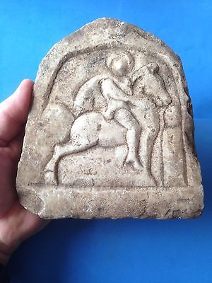

#### [THRACIAN HORSEMAN /RARE ANTIQUE VOTIVE TABLET](http://www.ebay.com/itm/322120592087)

|  |  |
| --- | --- |
| Item price | $544.41 |
| Quantity | 1 |
| Item number | 322120592087 |
| Shipping service | Royal Mail International Tracked |